**Route | Any Pickup, Any Deliver**

(Guideline)

Guidelines for the following:

**Order | Client | Router | Admin**

___________________________________________________________________________________

**ORDER:**

___________________________________________________________________________________

Only client can create the order, and order will be created only if client is logged in.

Client can go to the create order page in two ways:

1. From Home Page
2. From Client Dashboard

Following is the main and only page where a client can create an order.

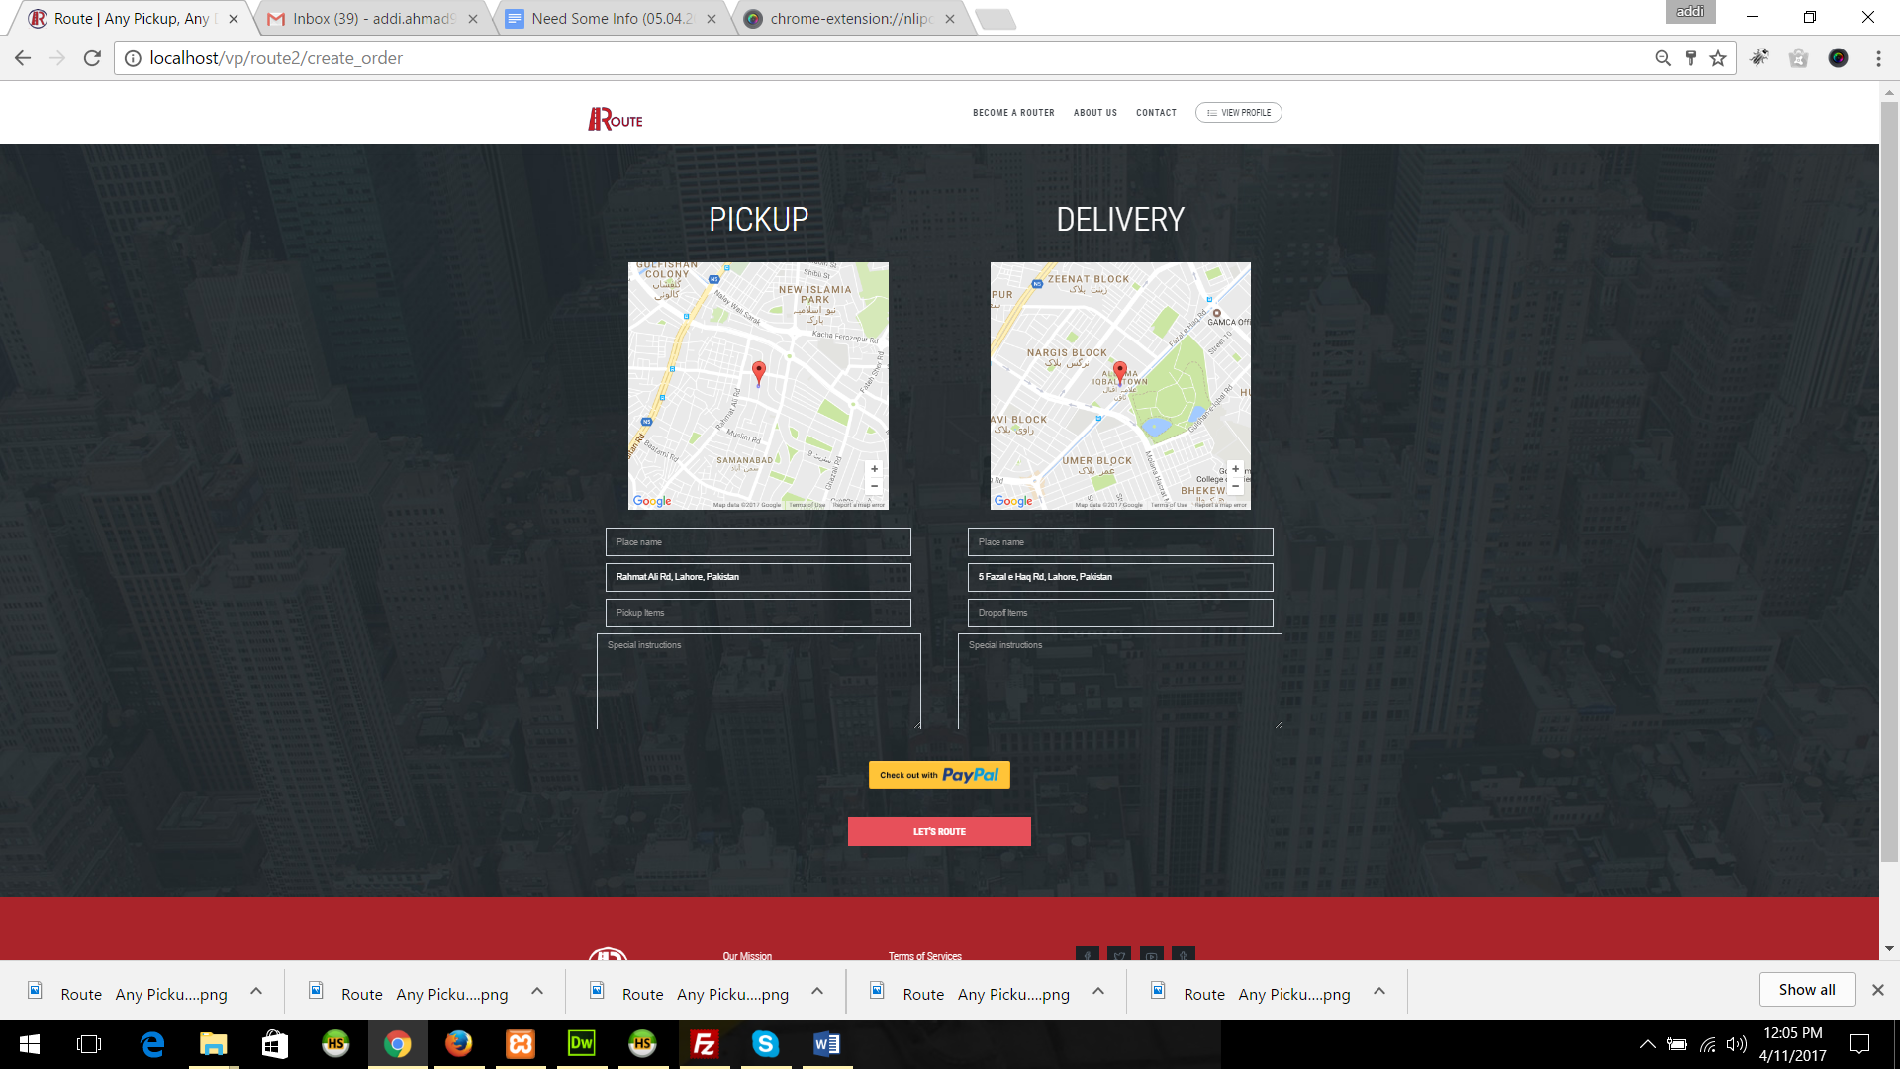

Once a client puts necessary information in input fields, and clicks on button “Lets Route”, there is a check if client is logged in OR not, if client is logged in, it’ll go to confirmation page, and if client is not logged in a sign in window will appear here.

Confirmation page of an order looks like the following:

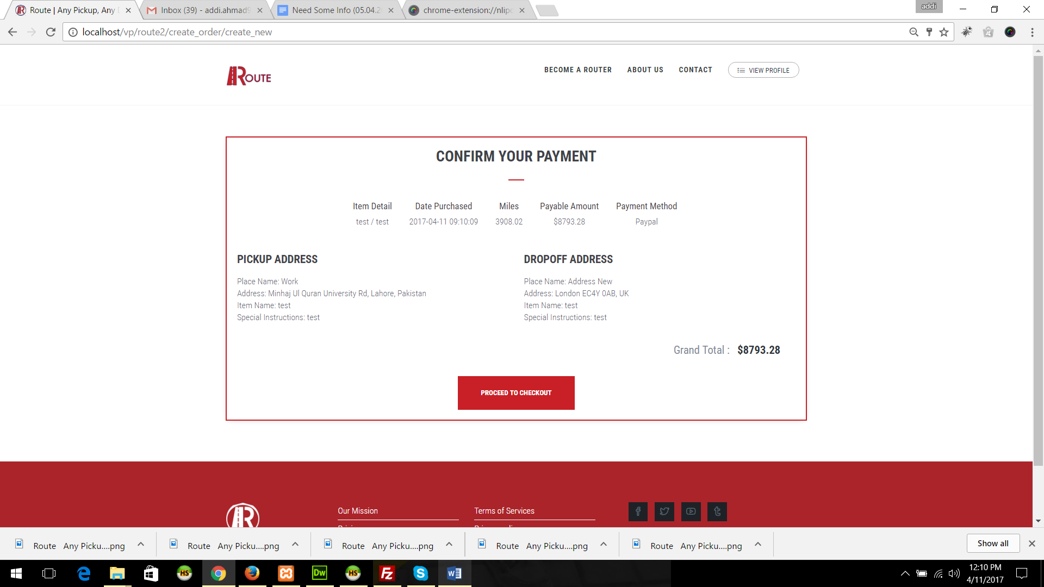

After clicking on proceed to checkout, client will redirect to the PayPal login, and client can pay from there, once a client clear the payment of order, it will redirect the client to the Payment Receipt Page which looks like the following:

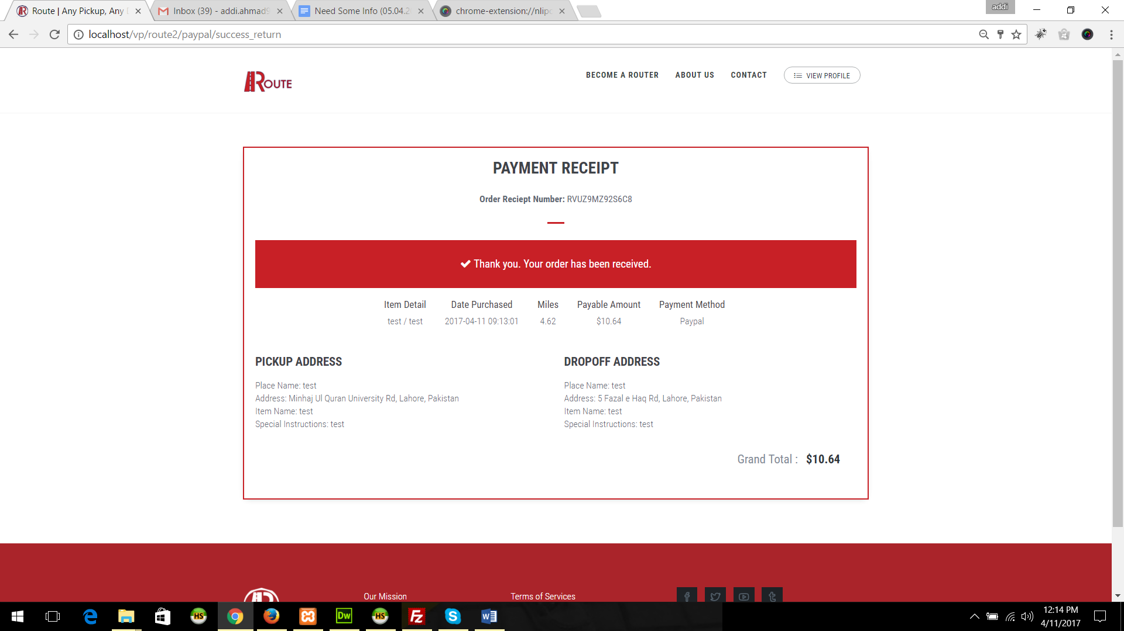

After creating an order everyone can see the order, admin, router and client. And order status will be active if payment is clear.

Once order is created, Any Router can see the un-assigned orders, you can see in the following image:

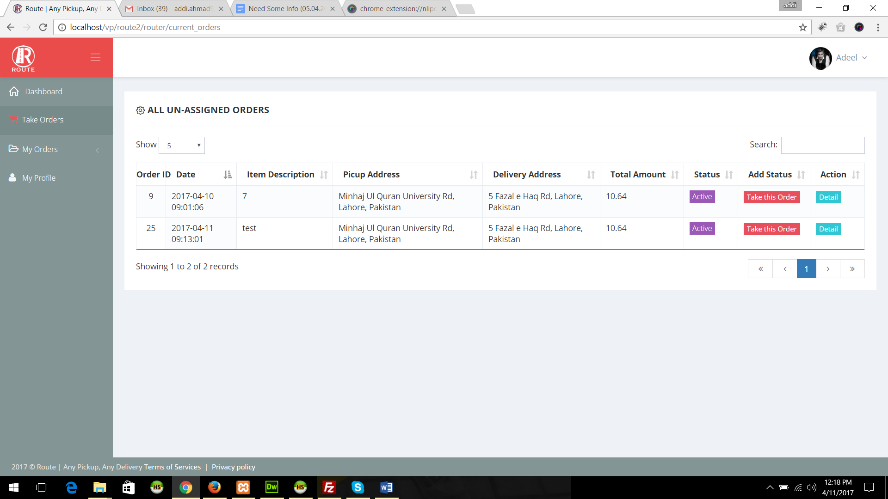

Once a router take the order by clicking on the button “Take this order”, it will disappear from here. It will shown on the Routers My Orders->Current Orders, it is showing in the following picture:

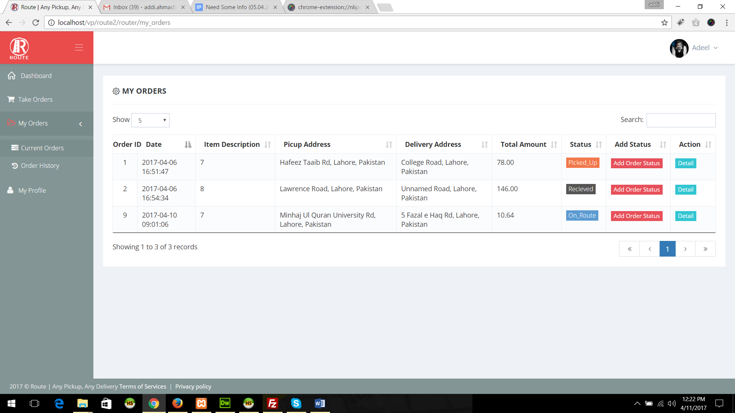

A router can add the status and can see the detail of complete order.

***Note: In this page only current running orders of a router will show. It will disappear once order is completed and completed orders will show on Router’s My->Orders->Order->History***.

___________________________________________________________________________________

**CLIENT:**

___________________________________________________________________________________

A client can be anyone from random peoples who visit route website.

**CLIENT SIGNUP PROCESS:**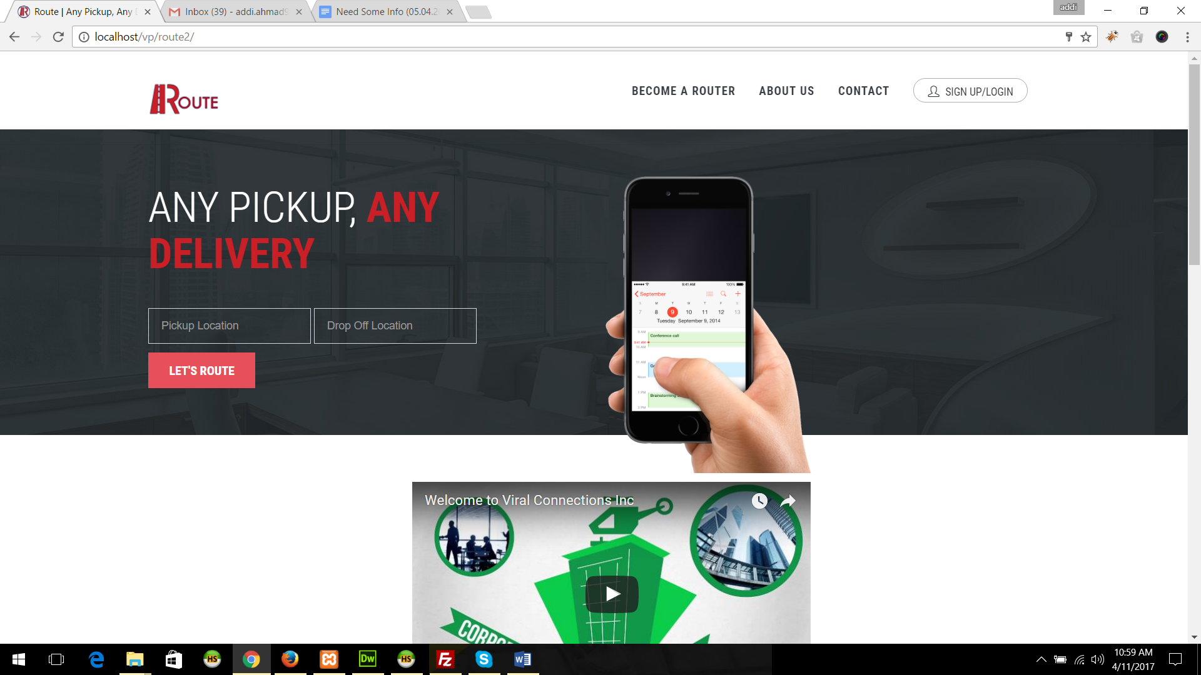

A client can create his account by filling form shown in the following image:

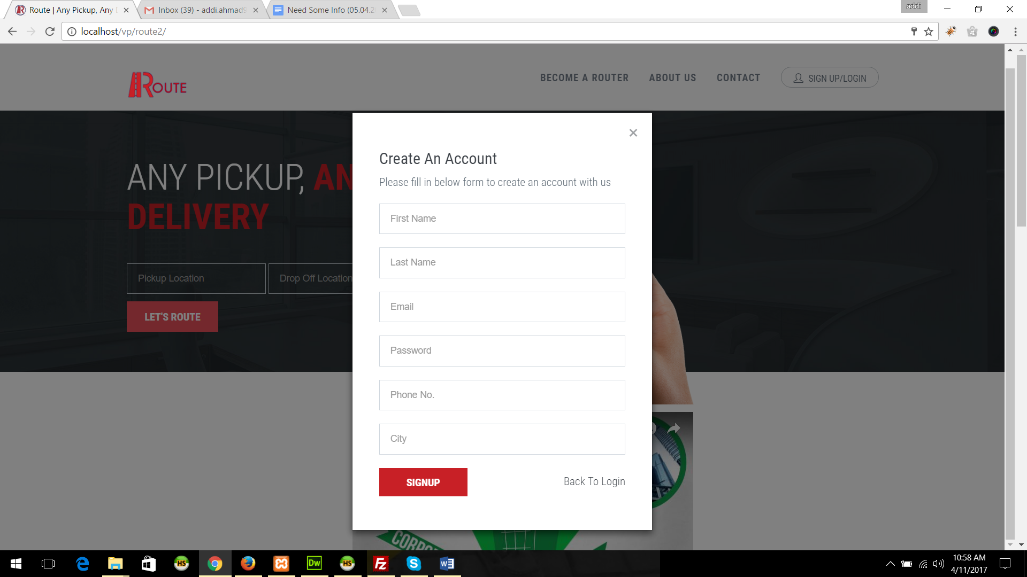

**CLIENT DASHBOARD:**

After creating account, client can login to his account and client dashboard is looks like:

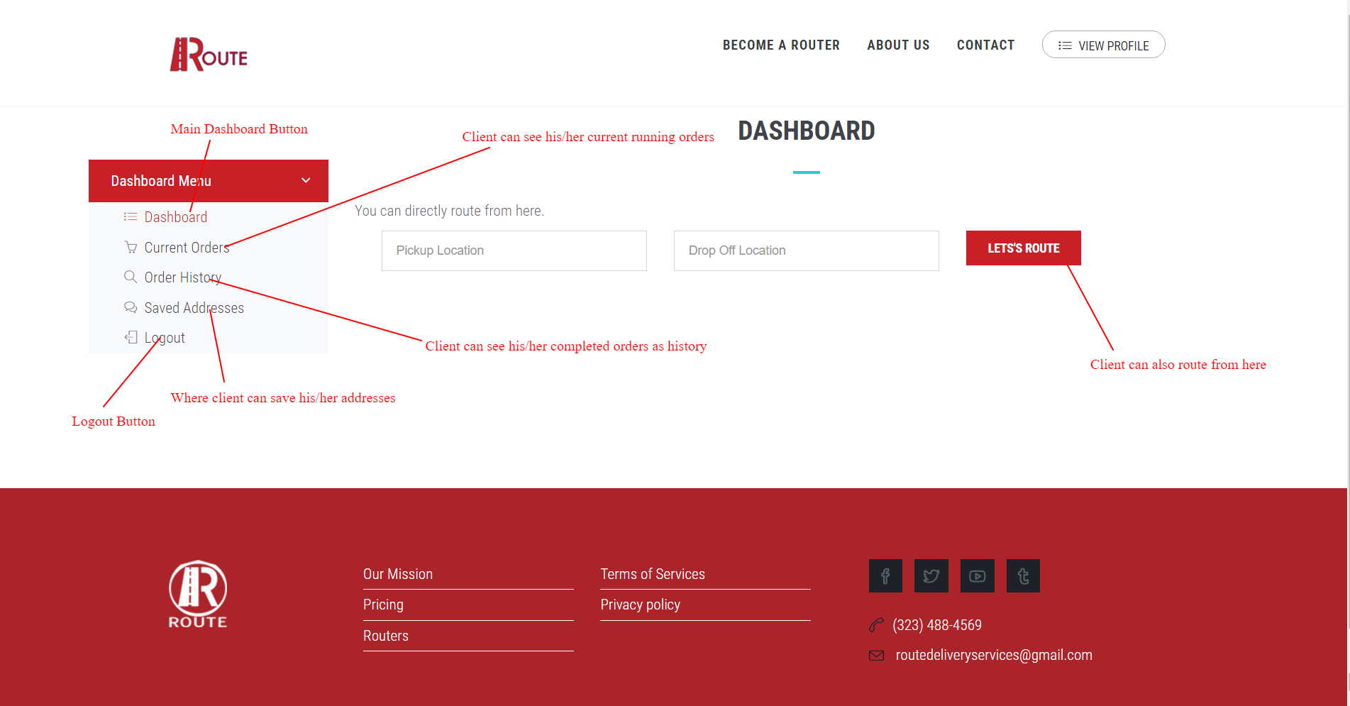

**CLIENT CURRENT ORDERS**

Client can see his current running order’s status in this page. And he can also rate the order and router order. This is order wise rating.

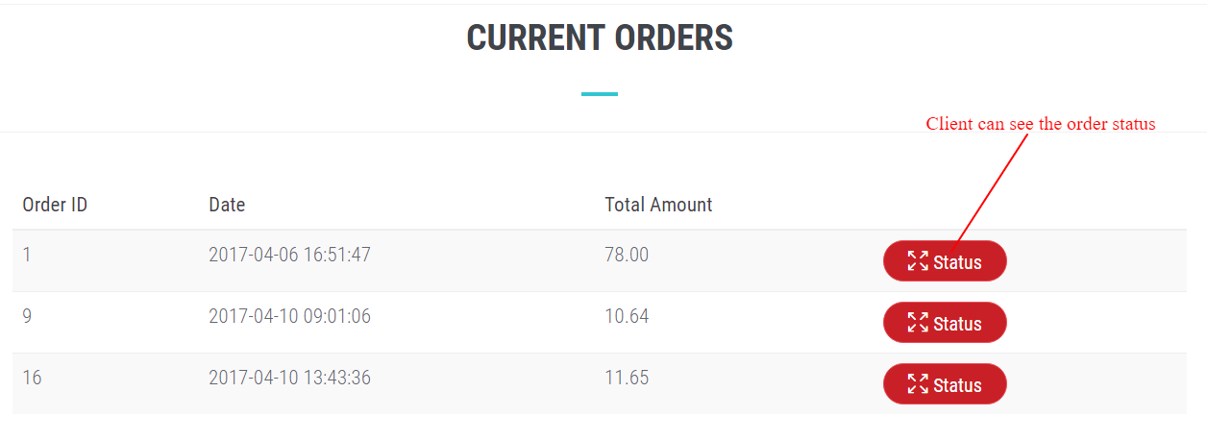

After clicking the status button a new window will appear, window is look likes the following:

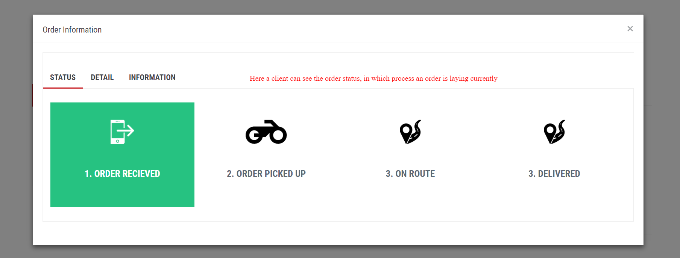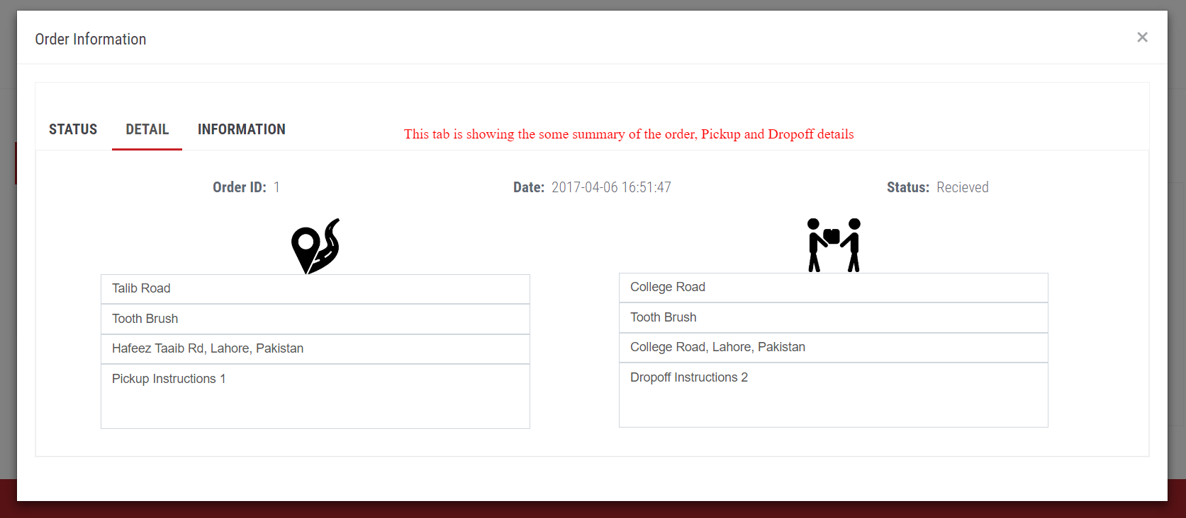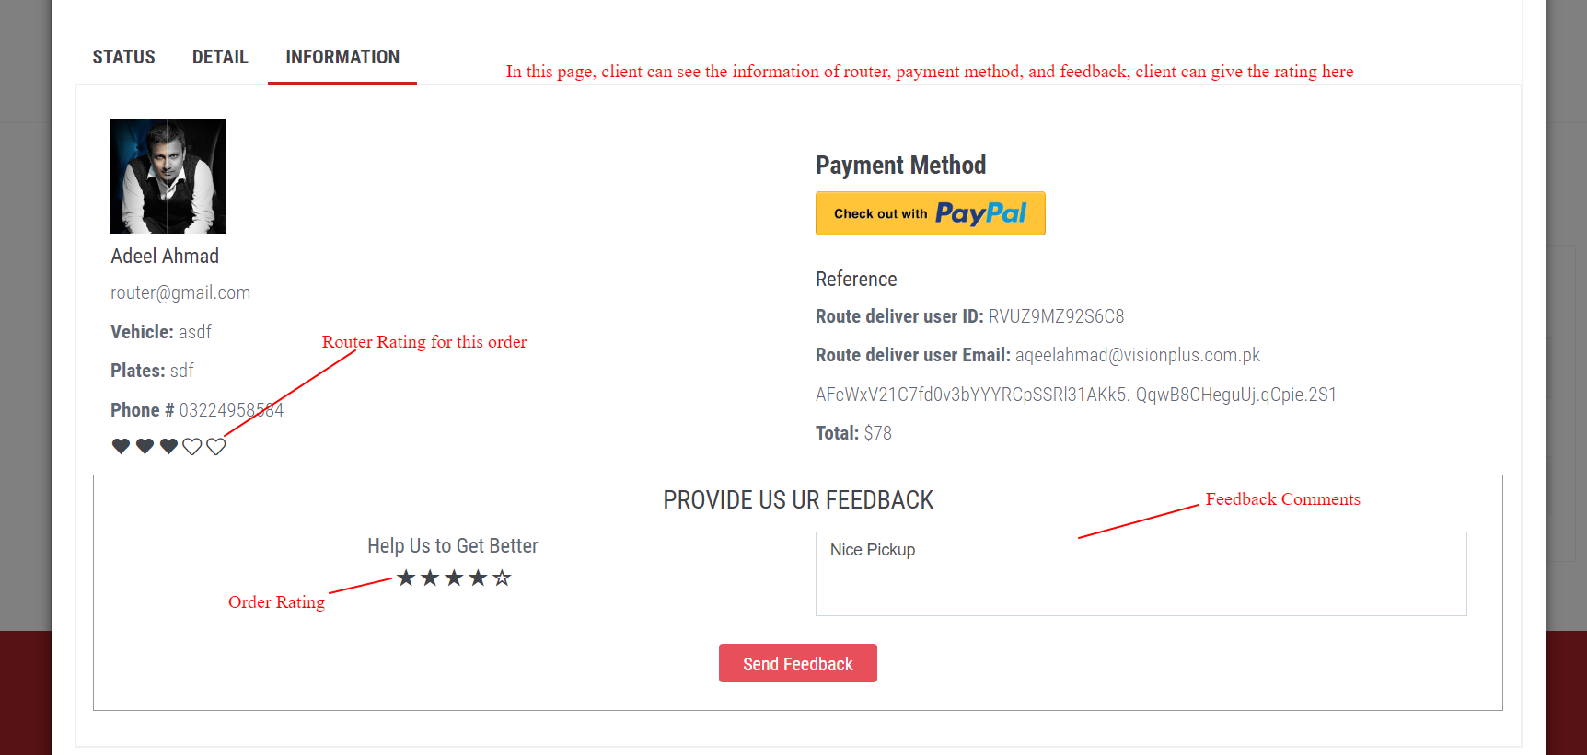

**CLIENT ORDER HISTORY**

Client’s Order History is the same as client current order, the only difference is, in order history client only can see the completed orders.

**CLIENT SAVED ADDRESSES**

In this page a client can save his/her most used places address, and it will autosuggest the client when creating an order.

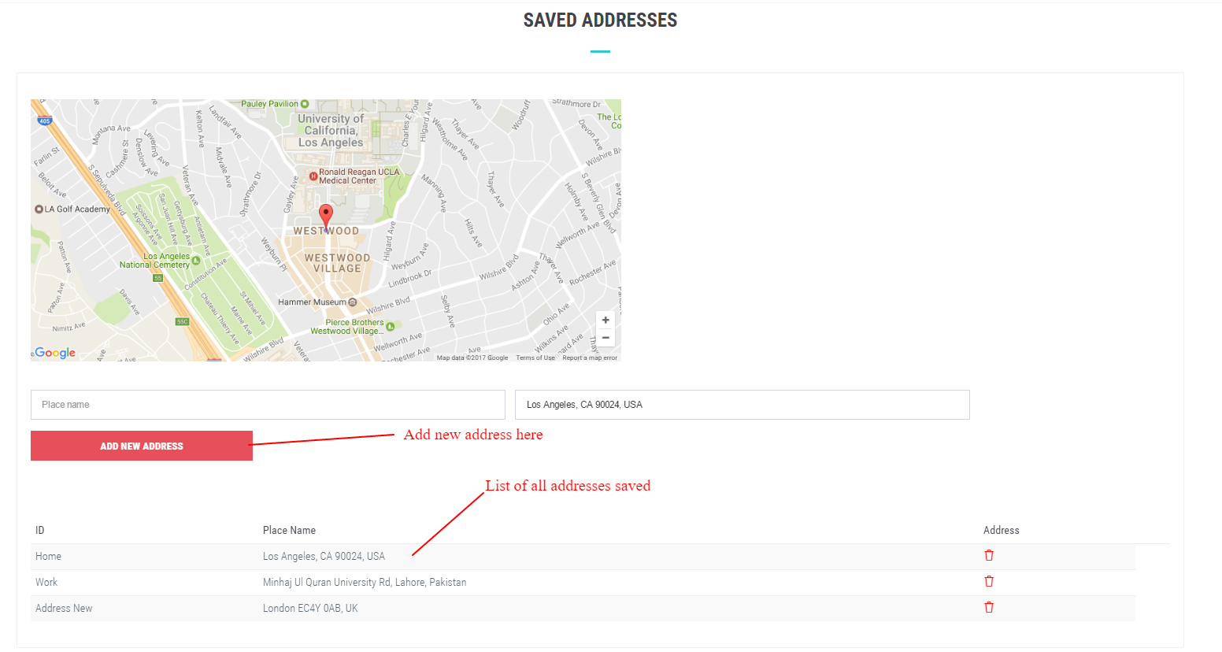

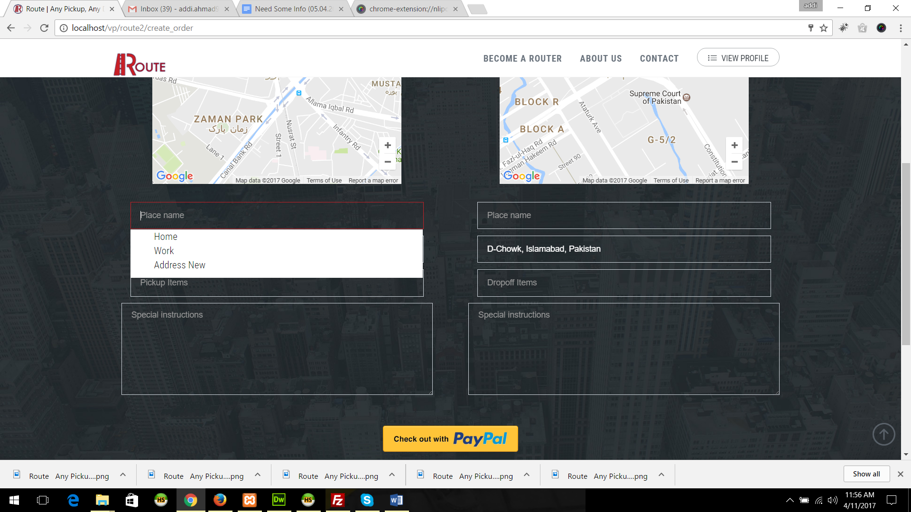

You can see the auto suggestion in the above picture.

___________________________________________________________________________________

**ROUTER:**

___________________________________________________________________________________

**BECOME A ROUTER**

1. Anyone can become a router after filling the form of become a router
2. Admin will receive the application and only admin has a right to approve OR reject the router.
3. If admin approve a driver/router he needs to assign the password to the router.
4. Router can log in by his/her email and your given password.
5. Admin can reject a router at any time.

**Router’s Profile**

Router can complete his/her profile as mentioned in the following picture:

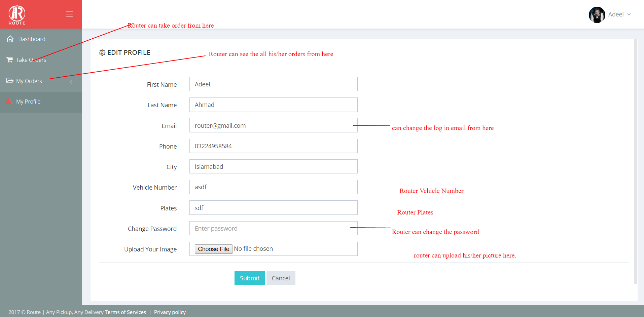

___________________________________________________________________________________

**ADMIN:**

___________________________________________________________________________________

